# A PROJECT

# REPORT

# On

# MUSIC APP

# Index

1. Description
2. Hardware Requirement
3. Software Requirement
4. Synopsis
5. Micro services
6. Conclusion
7. Use Case Diagram
8. Class Diagram
9. Flow Chart

# DESCRIPTION:

Fill your world with the songs, albums and artists that define you. Get unlimited access to millions of tracks, curated playlists and original content from the artists you know and love.

Music app is developed on spring boot. In music app we have player list which we can play the music track by searching artist name.

# SOFTWARE REQUIREMENTS:

1. JDK-11
2. MongoDB
3. Junit 5
4. Mockito
5. Spring Suite Tool IDE
6. Web Server
7. Postman
8. Git

# 3. HARDWARE REQUIREMENTS:

1. CPU: 1.2 GHz Processor

2. RAM: Minimum 1GB

3. Hard Disk: 10GB

# SYNOPSIS:

In Music application will be helpful for users. It gives better and smooth listening music experience. Using this application user can listen uninterrupted music without paying any charges. User can easily become stress less and being energetic after listening tracks which we are providing in this application. Lists of songs can be saved in to this application.

The user of this system should first register for any interaction with the system. Once registered, he/she will be provided with a username and password for the user to log in.After logging in the user should select the kind of activity he would like to perform like to choose category of music like pop, romantic, rock, jazz and so on. User can see current song name and details. User can also change tracks and songs whenever he/she wants.

# MICRO SERVICES:

1. Eureka service
2. Login and Signup
3. Playlist
4. Album
5. Contact Service

# MICRO SERVICES:

## Music Category

The User can choose favourite music as their own choice. User can also make changes and can add, remove the songs from list.

## PlayList

The user can create their playlist with id and they can add songs what they want. In playlist the user can also find artist name with song name.

## Album

The User can choose their album and they can see details like album name, song name, artist name

and they can view what songs they want.

## Contact Service

In this we have admin if user have any difficulty user can check the information and give the details.

# CONCLUSION:

Music player application provides various features like adding songs into different categories. User can add and delete songs. User has to register itself to access music player. User can play songs according to selected category. User can see the song details and can change track whenever he/she wants. User can use this service free of cost.

# USE CASE DIAGRAM:

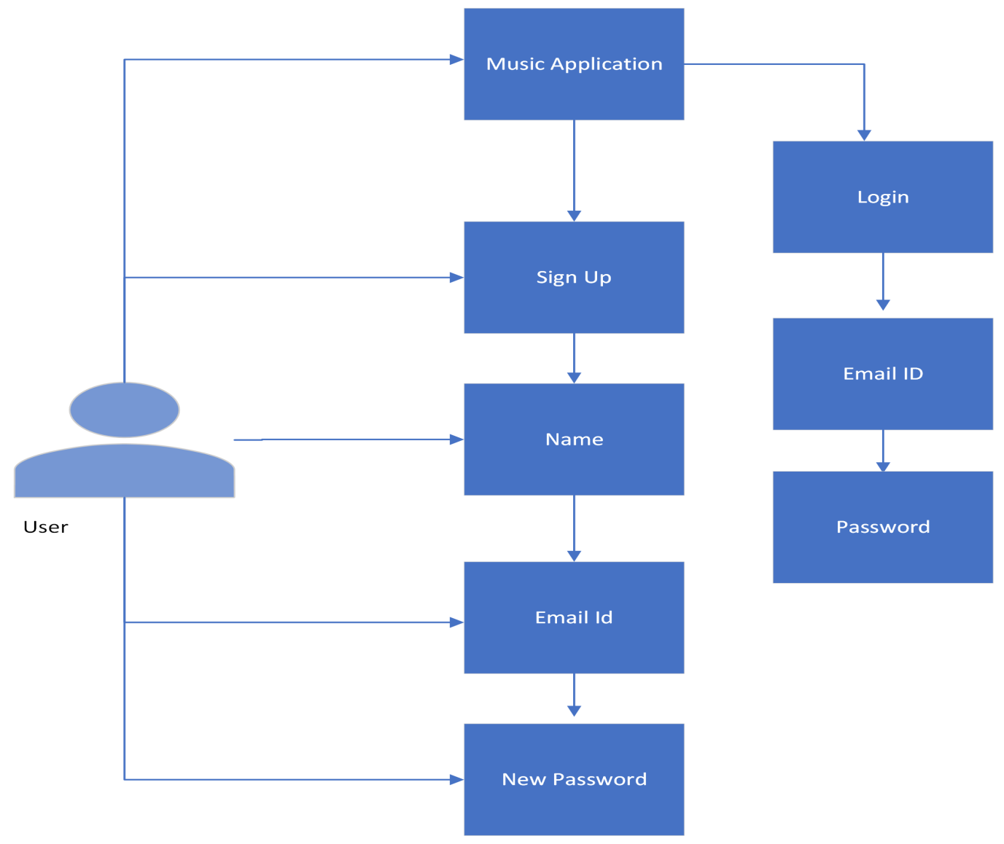

Fig: Use Case Diagram

# USE CASE DIAGRAM FOR USER AND ADMIN:

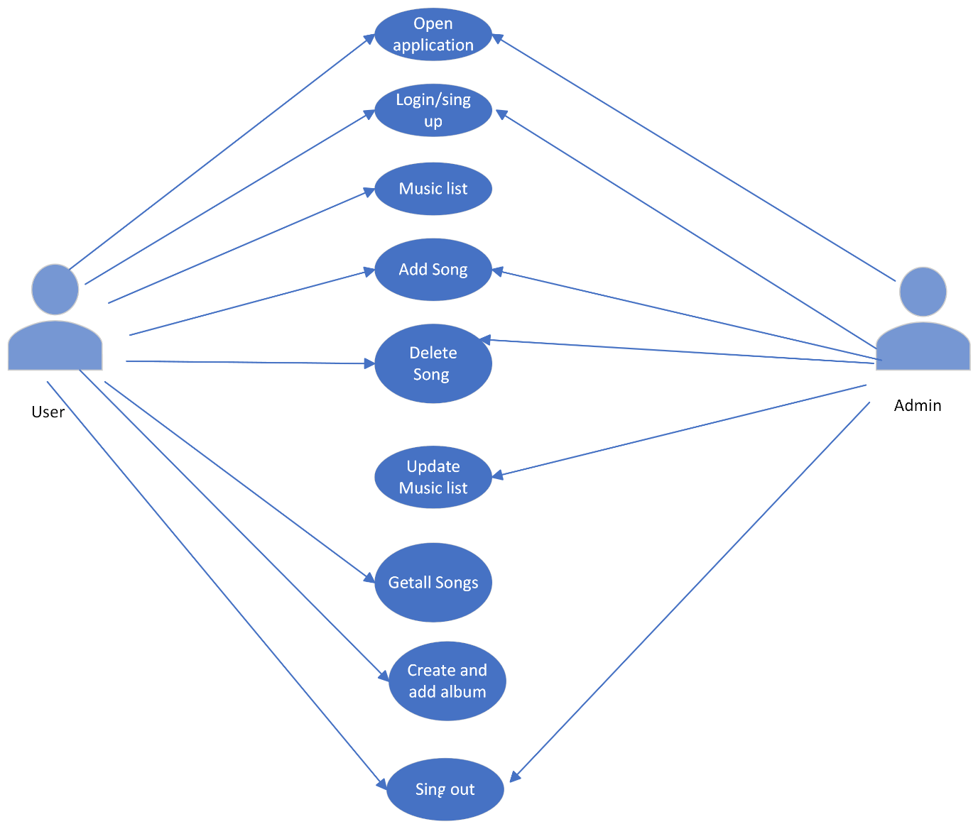

Fig: Use Case Diagram for User and Admin

# Class Diagram:

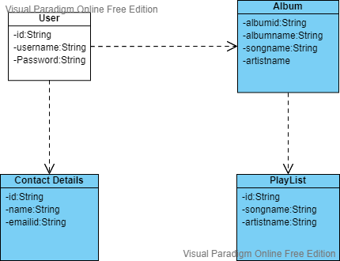

Fig: Class Diagram

# FLOW CHART:

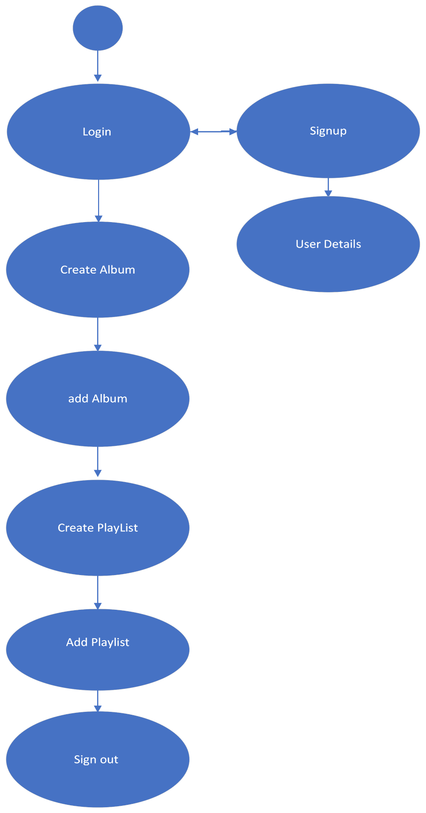

Fig: Flow Chart